QUICKIE BASKET

08

**Fall**

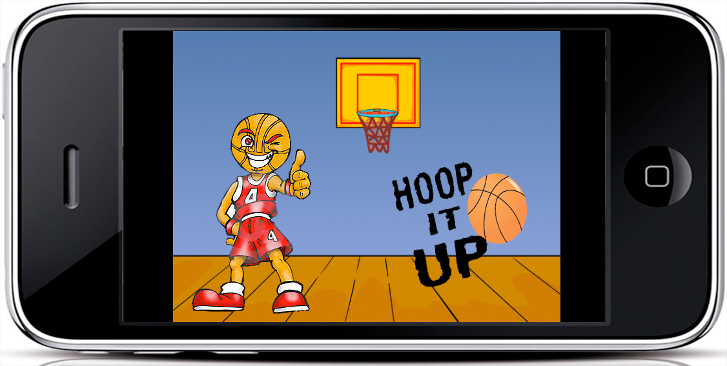

**JAKUB LEMISZEWSKI**

**CONTENTS**

**Introduction……………………………………………………………….. 3**

**Problem area……………………………………………………………… 3**

**Problem formulation…………………………………………………. 3**

**The Quickie Basket Game concept……………………………… 4**

**Quickie Basket – Description of the concept………………. 4**

**Target audience…………………………………………………………. 4**

**Target segmentation………………………………………………….. 4**

**User persona……………………………………………………………… 5**

**User scenario…………………………………………………………….. 5**

**Methodology.……………………………………………………………... 5**

**The Gamification business canvas model…………………… 6**

**Quickie Basket development process……………………… 7-8**

**User test…………………………………………………………………….. 9**

**1st user**

**2nd user**

**Future improvements………………………………………………… 9**

**Conclusions………………………………………………………………..10**

**References………………………………………………………………… 11**

**Appendices………………………………………………………….. 12-17**

**Introduction**

This project is in most general terms about the development of a game using the createjs library. This game should be easy, inviting and addictive. Something people can always bring with them even on their mobile devices.

**Problem area**

This modern era is dominated by mobile devices.

Everyone, children, young people and the older ones have a mobile device like a tablet or a smartphone. On these mobile devices people download everything, apps and games or anything else one can think of. Most of them play mobile games, like a very popular Candy Crash.

This new generation of players uses games as the relief from the daily life stress. Most of them play while commuting, on their way to work or school. They play during breaks but not only, they even play during working hours or during school lectures. They play to distract their minds for a moment from the surrounding environment.

People are addictive to such games because of their simplicity.

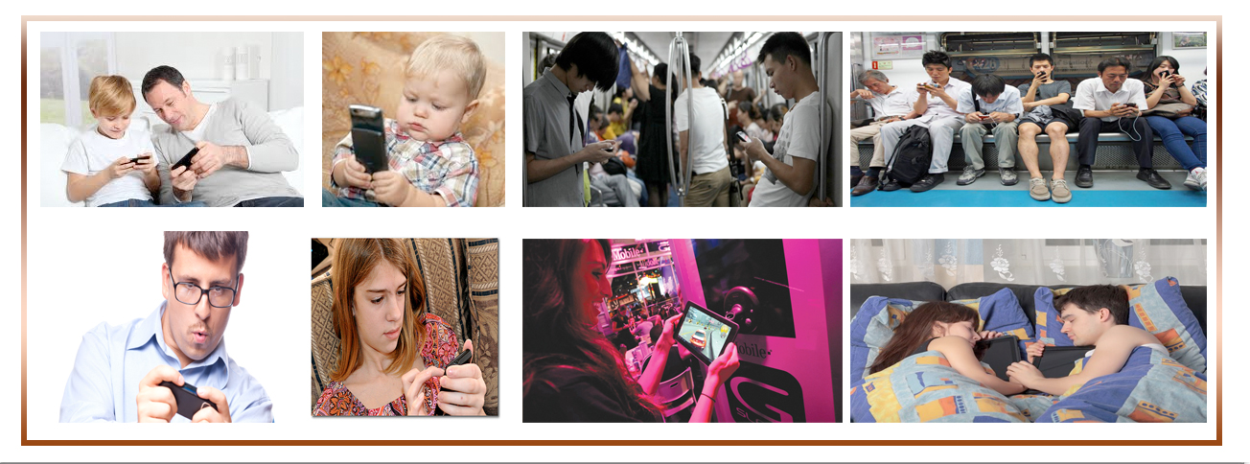

**Problem formulation**

How to develop a mobile game, make it interesting, easy to use and attractive to a large audience that will make them want to play again?

Some questions should be answered to solve that problem:

* Who is the target group?
* What tools should be used to make the game attractive to the audience?
* What strategy should be applied business wise?
* How to introduce The Quickie Basket game to the market so that it’s instantly visible and popular?

**The Quickie Basket Game concept**

The game is a very easy and intuitive basketball game, which in reality is about shooting the basketball to the hoop. It is designed and intended for people who are looking for a funny and simple mobile app to always have with them on their mobile devices. Quickie Basket is meant to be played on a smartphone or a tablet on any occasion such as on the train on the way to work or on the bus going to school, when you have a little time to kill or just want to relax and have fun. This is the game one will be looking for.

Simple, quick and funny.

**Quickie Basket – Description of the concept**

The concept of the game is based on a very simple idea of a figure of a basketball player shooting to the hoop. What one will see physically on the screen is the back of a basketball player and his arms throwing the ball to the hoop in front of him. The drawings are kept in a simple retro style. The game is of course about shooting as many baskets as possible in a given period of time which will conclude in gaining points.

The game is divided into several levels (the higher the level more difficult it gets). The player on the screen shoots to the basket that is moving in front of him. The higher the level the quicker the move of the basket and the difficulty.

**Target audience**

According to the Casual Games Association statistics tablet and smartphone games will have almost 28% of the global market, which makes it an obvious target for any game developer.

In the EU about 50% of the population owns a smartphone or a tablet or both.

In Denmark according to Gallup seven out of ten Danes own a smartphone. There is also over a million tablets on Danish market.

This information implies that Quickie Basket could easily find an audience both in Denmark but also worldwide.

**Target segmentation**

According to the Casual Games Association statistics 41% of the EU population between 20-35 years old play mobile games. The future growth of the market is estimated at 25% per year.

**User persona**

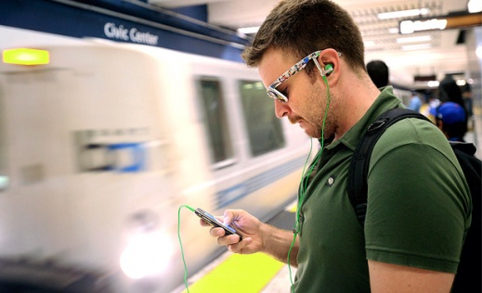Miles (Fig 1) 22 years old, a university student in Copenhagen. Miles’s day is all about studys either at the university (attending lectures) or at home preparing his tests and studying. Apart from that Miles is a sports fan and a passionate active

basketball player.

Fig 1

**User scenario**

Miles lives on the outskirts of Copenhagen. That means that he has to commute between home and the university every day. He spends approximately 40 min on the train each way. He naturally has sometime to kill. He gladly spends that time playing mobile games on his smartphone or tablet. He does it also between the classes at the university or while eating lunch.

**Methodology**

The newest trends in introducing products on the market imply that the pleasure feeling is a very important factor in developing mobile games. One can dived this in to four types of pleasure.

|  |  |
| --- | --- |
| **Physical Pleasure**    The game will play different sounds when the player makes or misses a basket. | **Social Pleasure**    The game offers the players social pleasure because it will be possible to play the game online with the others. |
| **Psychological Pleasure**    The player of the game will experience psychological pleasure becoming better and better and by beating his opponents online. | **Ideological Pleasure**    Ideological pleasure is gained from the fact that the player becomes more and more skilled and gets to higher and higher levels. |

**The Gamification business canvas model**

**MECHANICHS**

The score determines entering higher levels.

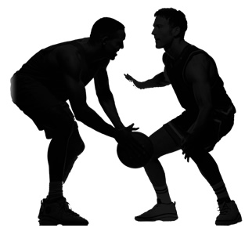

**PLAYERS**

Persons between 20-35

Years

Basketball freaks

Students and workers

**REVENUES**

Subscription**,** downloads.

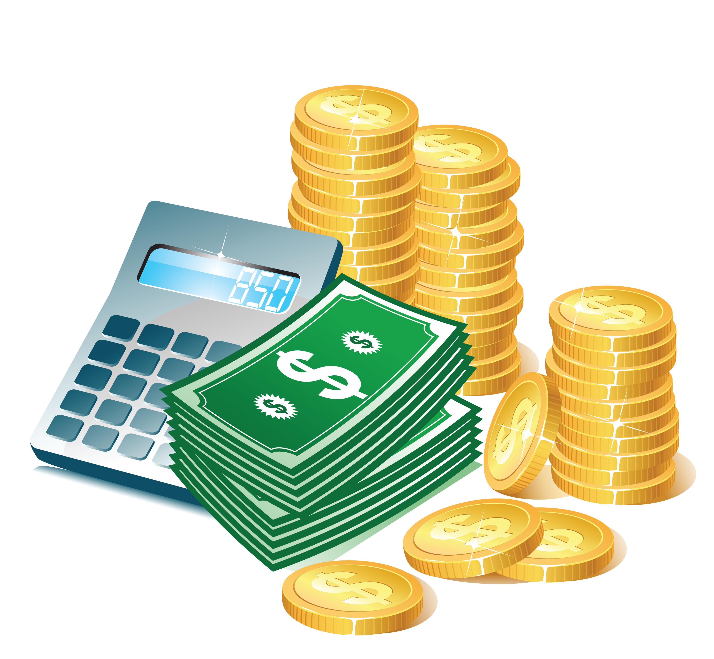**COSTS**

Developing, maintaining, improving, promotion.

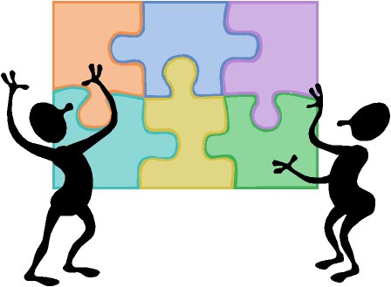

**BEHAVIORS**

Players feedback online.



**AESTHETICS**

Challenge

Fellowship

Fantasy



**DYNAMICS**

Shooting the maximum amount of baskets in the given time stretch.



**COMPONENTS**

Scores, rewards, avatar, ball, countdown.

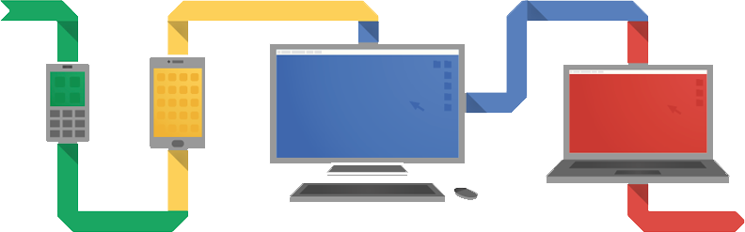

**PLATFORMS**

Mobile devices:

Smartphones

Tablets

This model serves for a better understanding of how potential clients will react and how therefore more money will be made by constant improvements of the game.[1]

**Quickie Basket development process**

The process began with simple sketches on paper and little hand notes written on the side. The design idea is extremely simple which also reflects the simplicity of the idea of the game on the whole[2].

Simple sounds and comments for the player had to be found.

The idea of the final form was to keep the drawings in the retro style, which made it more humorous. (Fig 2)

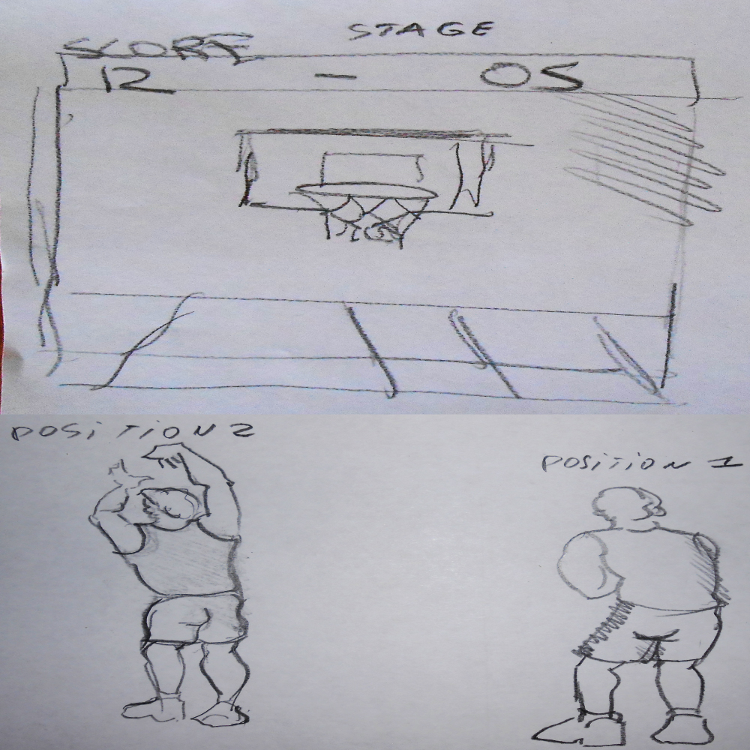

Fig 2 Sketches of the game

JavaScript, html5 and css are coding languages used to create the game. In particular JavaScript library- createjs was used (Fig 3).

The method of object orienting programming was used in this case and media queries for a responsive design[3]. Also are used UML diagrams[4].

Fig 3 Code sample from promt.js

(function (library, img, cjs) {

(library.bonusPoints = **function**() {

*//Show message on the screen*

**this**.bonusPromptArtworkVar = **new** library.bonusPromptArtwork();

**this**.addChild(**this**.bonusPromptArtworkVar);

}).prototype = **new** cjs.Container();

(library.LevelPrompt = **function**() {

*//Play Button*

**this**.playBtnVar = **new** library.playBtn();

**this**.playBtnVar.x=220;

**this**.playBtnVar.y=365;

*/*Hight Score???????????????*

*this.highScoreBtnVar = new library.highScoreBtn();*

*this.highScoreBtnVar.x=220;*

*this.highScoreBtnVar.y=565;*

*\*/*

*//Text Prompt*

**this**.instructions = **new** cjs.Text("", "bold 16px 'Arial'", "#FFFFFF");

**this**.instructions.name = "instructions";

**this**.instructions.textAlign = "center";

**this**.instructions.lineHeight = 18;

**this**.instructions.lineWidth = 148;

**this**.instructions.x=334;

**this**.instructions.y=147;

**this**.level_txt = **new** cjs.Text("", "35px 'Comic Sans MS'");

**this**.level_txt.name = "level_txt";

**this**.level_txt.textAlign = "center";

**this**.level_txt.x=327;

**this**.level_txt.y=49;

**this**.addChild(**this**.playBtnVar);

*//this.addChild(this.highScoreBtnVar);*

**this**.addChild(**this**.instructions);

**this**.addChild(**this**.level_txt);

}).prototype = **new** cjs.MovieClip();

**User test**

Ones the game prototype was finished the think-a-loud test was applied to try it out. The players were asked to express their thoughts while playing the game through the Internet.

**1st user and his comments**

**Daniele Tognocchi 29 years Italy:**

“I think the game is very simple, maybe to simple?

I liked the colors and the retro style and I really liked the sounds of the game and I enjoyed playing it.”

**2nd user and his comments**

**Jens Larsen 25 years Copenhagen:**

“I thought the game is real fun but I really missed the possibility of connecting with the social networks… Maybe the difficulty should be bigger… I also like a more sophisticated scoring system and maybe a option of creating a personal profile.”

**Future improvements**

Better colors.

More sophisticated level stages.

More detailed and differentiated ways of shooting.

Improved sounds.

A richer choice of personal preferences.

Connection to the social networks.

A better way of rewarding the player after each finished level.

High-score system[5].

Ranking online system.

**Conclusions**

The idea of the game is a good one but needs further improvements in terms of graphics, sound and features. The single levels of the game must be defined better so that the player enjoys the game much more. It’s vital to figure out a good business plan to be able to sell the game. Most probably a small group effort would increase the outcome due to the fact that each group member could focus on one aspect of the problems to be solved since even a theoretically simple project like the Quickie Basketball Game needs to be looked at from many aspects both design and technical aspects to achieve the desired result and a good quality product that will have a good chance to be introduced on the market. The last but not the least is the fact that the game can be proposed to the mobile app stores only if coded in C#, C++ or Java coding languages.



**References**

**Smartphone & tablet gaming report 2013**

http://issuu.com/casualconnect/docs/cga_market_report_fall2013?e=2336319/6014071#search

**Computerworld**

http://www.computerworld.dk/art/227284/saa-mange-danskere-har-en-tablet-og-en-smartphone

**Gamification business canvas model**

<http://www.gameonlab.com/>

**Createjs**

<http://createjs.com>

**Appendices**

**Gamification business canvas model**

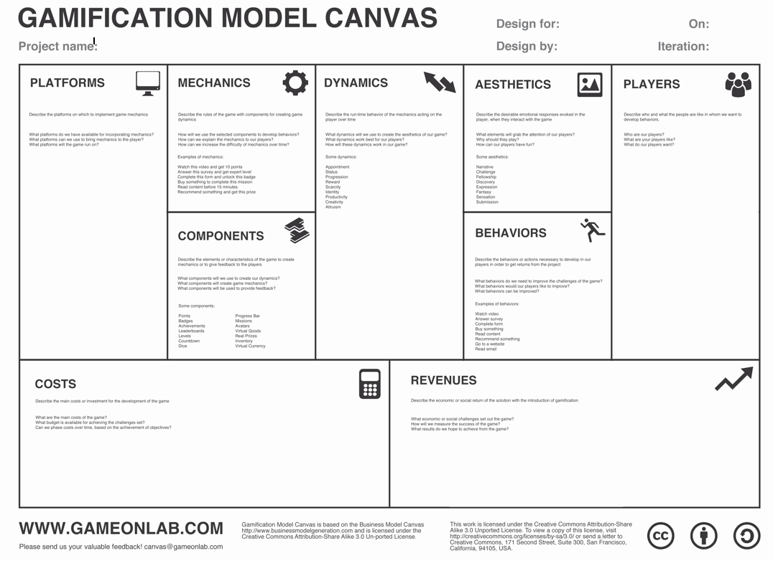

**Style elements & Game screenshot**

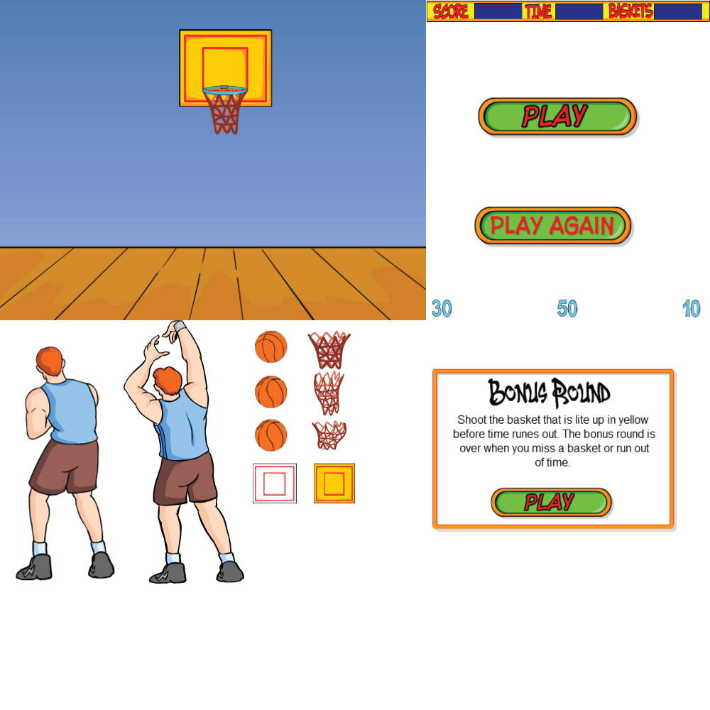

**Main stage and Bonus level**

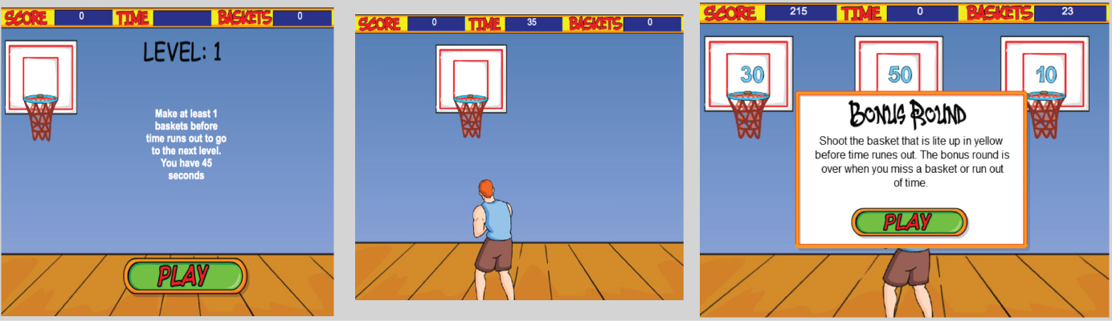

**Code of the index.html**

<!DOCTYPE html>

**<html>**

**<head>**

**<meta** charset="UTF-8"**>**

**<title>**Basketball**</title>**

*<!--############ Createjs Libs##########################################################-->*

*<!--<script src="createjs-2013.12.12.min.js"></script>--><!-- Entire lib -> offline -->*

**<script** src="http://code.createjs.com/easeljs-0.7.0.min.js"**></script>**

**<script** src="http://code.createjs.com/tweenjs-0.5.0.min.js"**></script>**

**<script** src="http://code.createjs.com/movieclip-0.7.0.min.js"**></script>**

**<script** src="http://code.createjs.com/preloadjs-0.4.0.min.js"**></script>**

**<script** src="http://code.createjs.com/soundjs-0.5.0.min.js"**></script>**

*<!--########### End ####################################################################-->*

*<!--########### Scripts js #############################################################-->*

**<script** src="basketballMain.js"**></script>**

**<script** src="player.js"**></script>**

**<script** src="basketballboard.js"**></script>**

**<script** src="ball.js"**></script>**

**<script** src="butons.js"**></script>**

**<script** src="winLostBackgrounds.js"**></script>**

**<script** src="promts.js"**></script>**

**<script** src="loadSettings.js"**></script>**

**<script** src="basketBallGame.js"**></script>**

*<!--########### End #############################################################-->*

*<!--########### Viewport devices mobile #############################################################-->*

**<meta** name="viewport" content="width=device-width, initial-scale=1, maximum-scale=1"**>**

*<!--########### Style ####################-->*

**<style>**

#canvas {

**left**: 23.5%;

**position**: **absolute**;

**width**: 55%;

**height**: 70%;

**overflow**: **hidden**

}

**body** {

**margin**: 4% **auto**;

**padding**: 0;

}

*/* ######## Mobile devices -> Smatrphones general landscape ################# */*

**@media** **only** **screen** **and** (**min-width**:321px) {

**body** {

**margin**: 8% **auto**;

}

#canvas {

**width**: 65%;

**height**: 70%;

**left**: 18%;

}

}

*/* ###### Screen devices 800px -> 1024px ########### */*

**@media** **all** **and** (**min-width**:800px) **and** (**max-width**:1024px) {

**body** {

**margin**: 10% **auto**;

}

#canvas {

**width**: 65%;

**height**: 70%;

**left**: 18%;

}

*/* ###############END############################# */*

**</style>**

**<script>**

**var** canvas,

stage,

mainParentLibrray;

*/*initialisation stuff*/*

**function** init() {

createjs.MotionGuidePlugin.install();

canvas = document.getElementById("canvas");

images = images|| {

}

;

**var** loader = **new** createjs.LoadQueue(**false**);

loader.installPlugin(createjs.Sound);

loader.addEventListener("fileload", handleFileLoad);

loader.addEventListener("complete", handleComplete);

loader.loadManifest(library.loadSettings.filesToLoad);

stage = **new** createjs.Stage(canvas);

createjs.progress = **new** createjs.Text("LOADING...", "45px 'Arial'", "#000000");

createjs.progress.textAlign = "center";

createjs.progress.x=280;

createjs.progress.y=220;

createjs.Ticker.setFPS(24);

createjs.Ticker.addEventListener("tick", stage);

stage.addChild(createjs.progress);

}

*/*Load img*/*

**function** handleFileLoad(evt) {

**if** (evt.item.type == "image") {

images[evt.item.id] = evt.result;

}

}

*//When complete load -> add stage*

**function** handleComplete() {

mainParentLibrray = **new** library.basketBallGame();

stage.addChild(mainParentLibrray);

stage.update();

stage.removeChild(createjs.progress);

}

*/*Sound*/*

**function** playSound(id,

loop) {

createjs.Sound.play(id, createjs.Sound.INTERRUPT_EARLY, 0, 0, loop);

}

**</script>**

**</head>**

**<body** onload="init();" style="background-color:#D4D4D4"**>**

**<canvas** id="canvas" width="600" height="450" style="background-color:#FFFFFF"**></canvas>**

**</body>**

**</html>**

**UML diagram (prototype based code) V1**

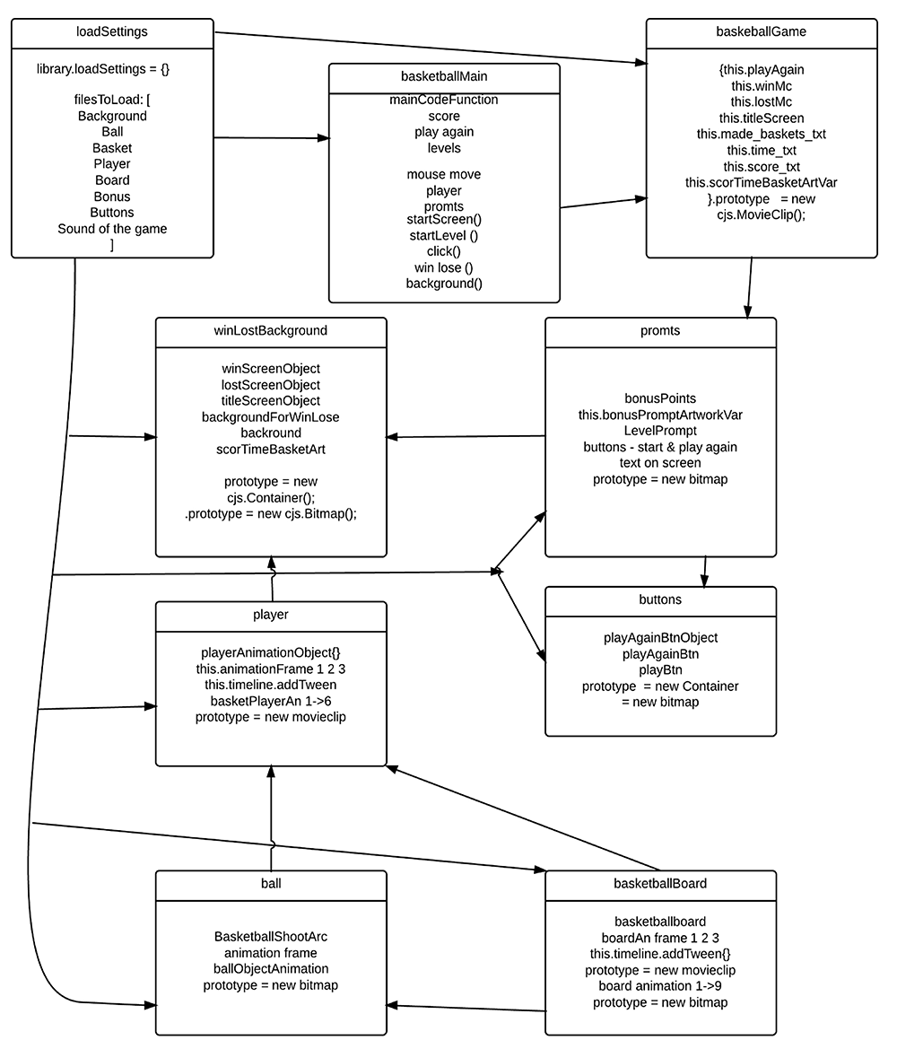

**UML diagram V2**

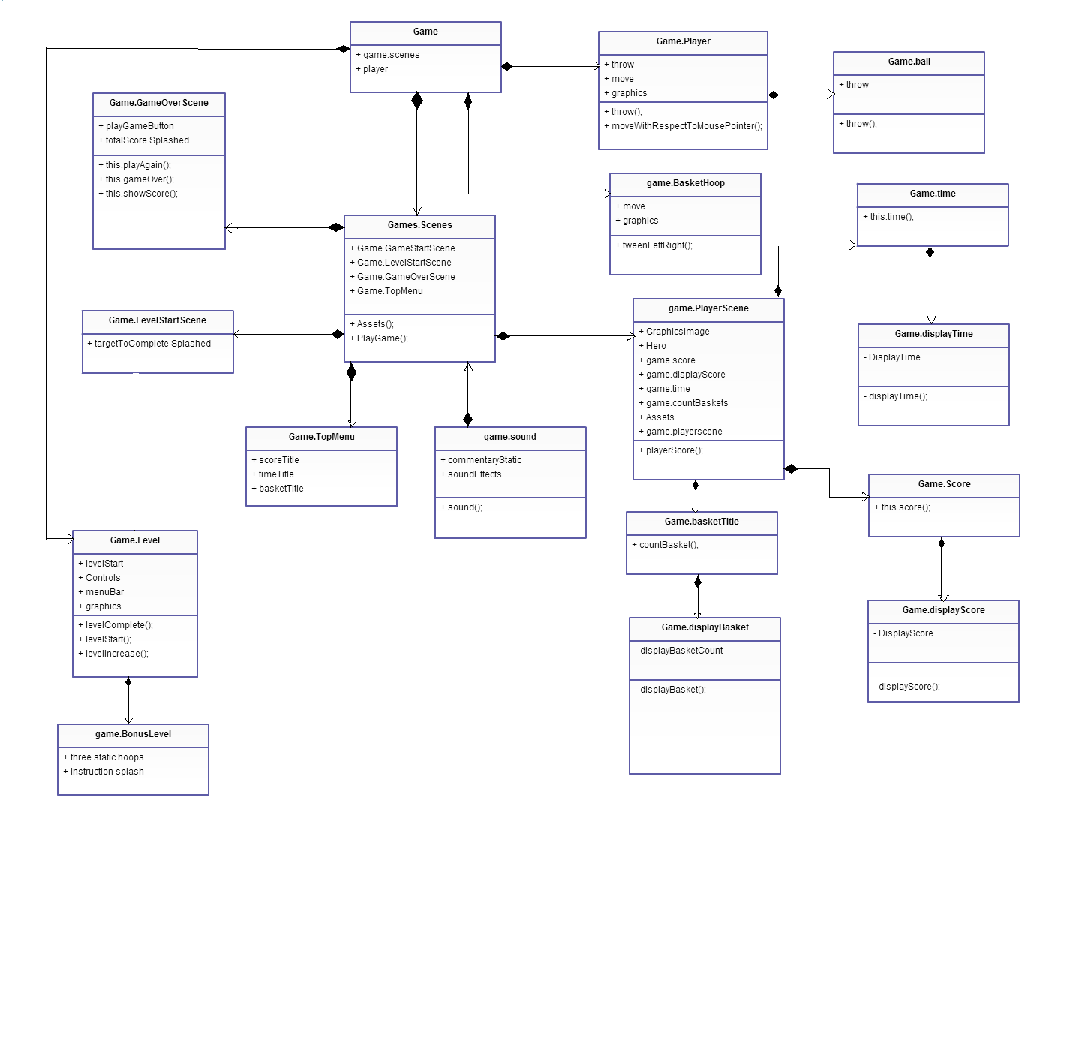

1. Appendices page 12
2. Appendices page 13
3. Appendices page 14-15
4. Appendices page 16-17
5. high-score testing of the game on URL:

   ” <http://jaku0260.keaweb.dk/testing/> ”